We currently have a topology that includes a server and multiple VLANs (user PCs).
Our goal is to create a policy that allows these VLANs to access the server, including shared files and other services.
First Step :
Network >>>> Interfaces >>>> Create New
Create Interfaces for vlan from (10 to 50)
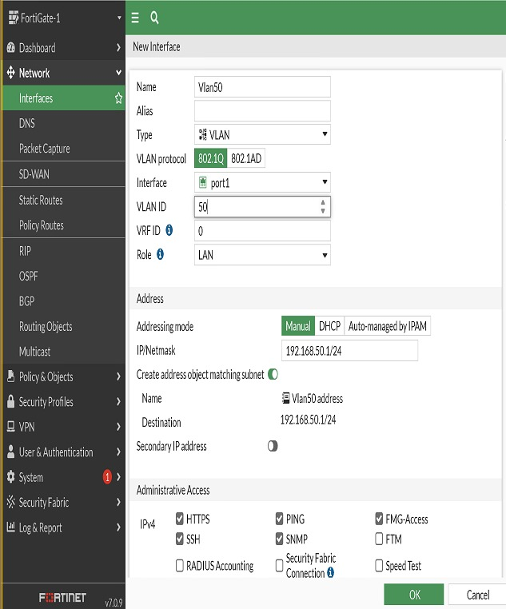
Create Server_Vlan 60 >>>> subnet (192.168.60.1/24)
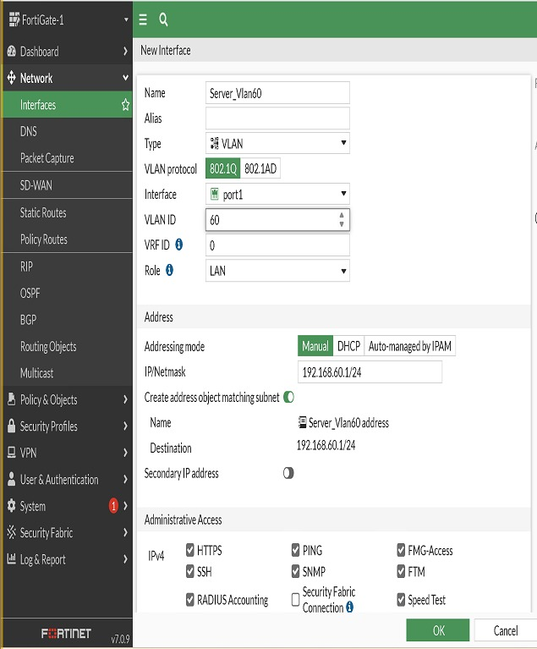
Create Group ( Zone ) for all users (all Vlans) :
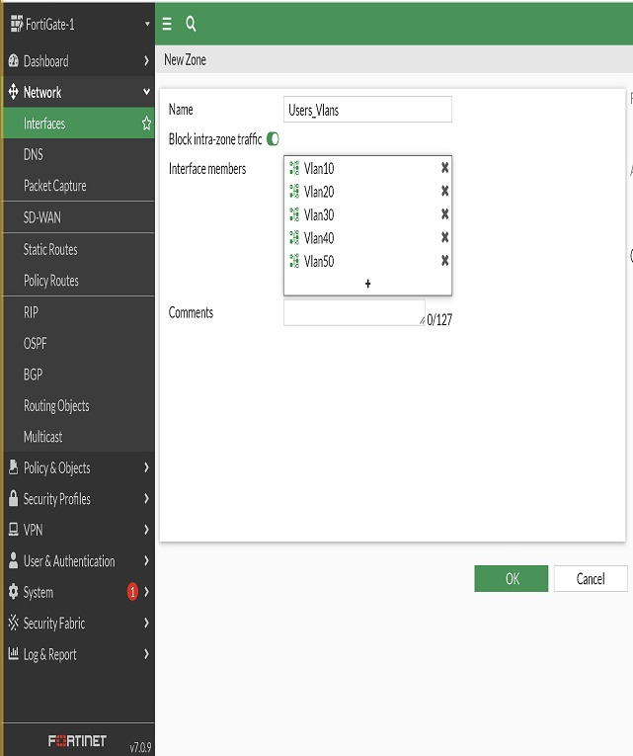
Second Step :
Policy & Object >>>>> Address
Assign an IP address to each interface
We find address (for every vlan we did it )in the section of interface subnet
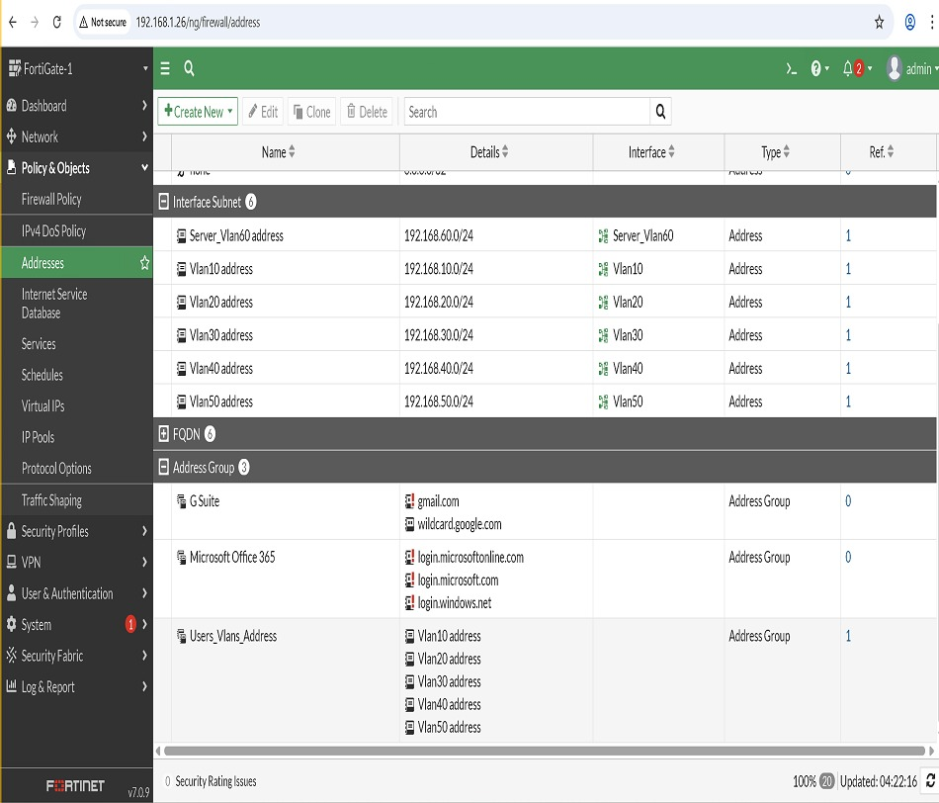
we will create Address Group for users
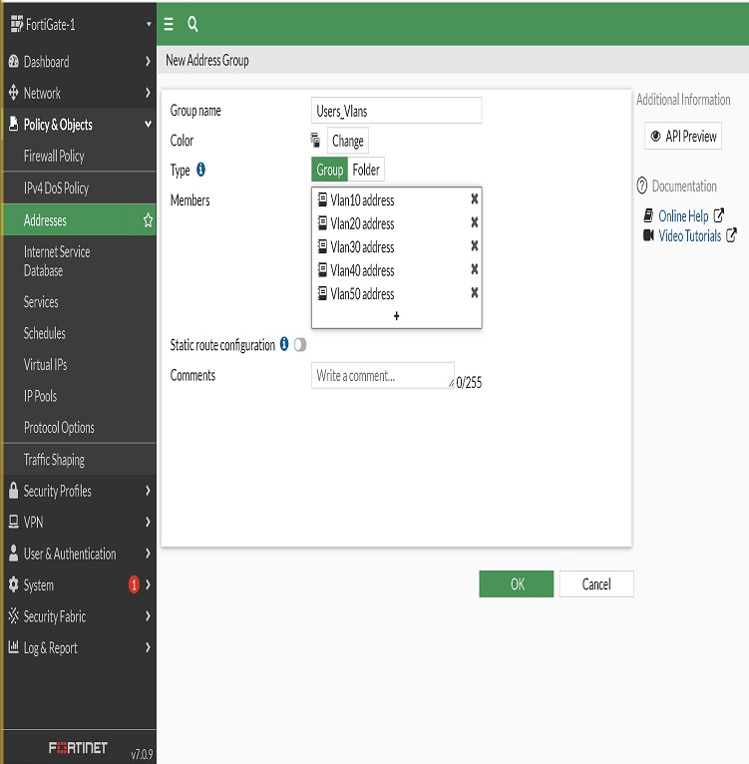
then assign ip for server in its vlan (vlan 60)
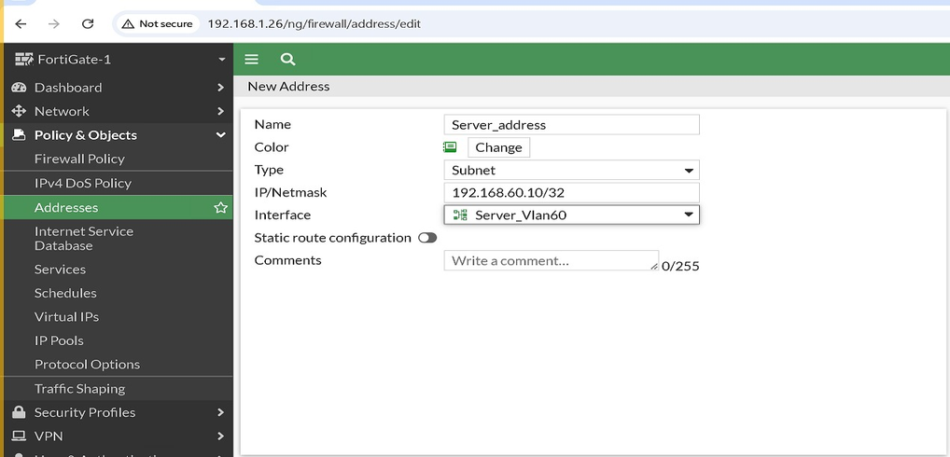
Third Step:
Policy & Object >>>>> Firewall Policy >>>> Create new
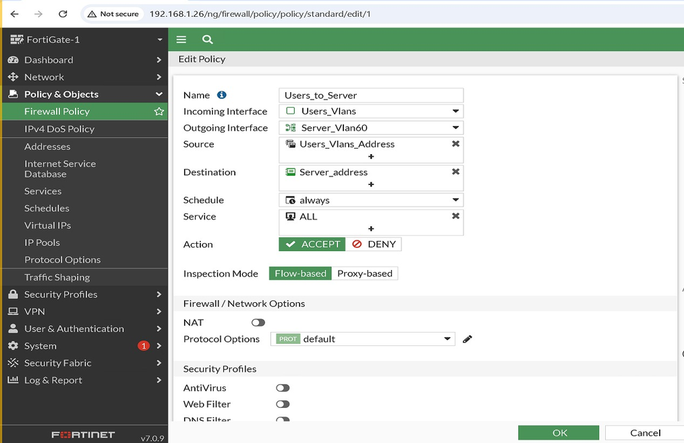
disable Nat and enable all Session log in
Make sure that fortigate see server :
write execute ping 192.168.60.10 in CLI
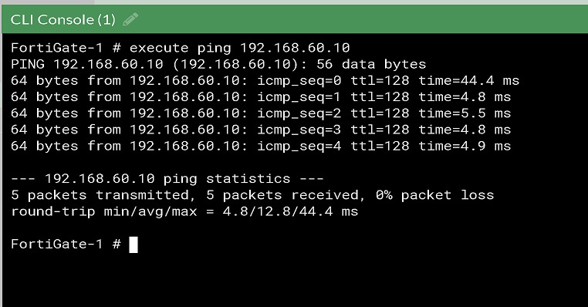
Make sure that pcs see Server :
